**Fix for the problem of logs not getting uploaded**

* Created the log configuration with run as user root
* Created config with runas user root  
  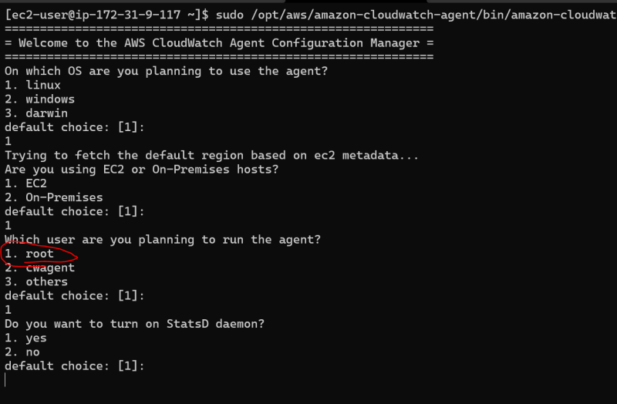
* Then executed sudo /opt/aws/amazon-cloudwatch-agent/bin/amazon-cloudwatch-agent-ctl -a fetch-config -m ec2 -c file:/opt/aws/amazon-cloudwatch-agent/bin/config.json
* Restarted the cloudwatch log agent

sudo systemctl restart amazon-cloudwatch-agent.service

* Verified in the agent log  
  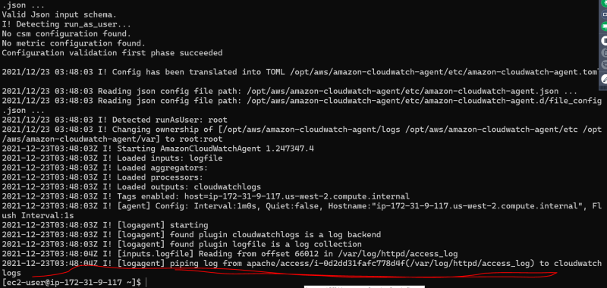

**Gaining insights from the logs**

* <https://docs.aws.amazon.com/AmazonCloudWatch/latest/logs/CWL_QuerySyntax.html> for the Log insights query syntax
* General Queries
* Show 100 logs  
  fields @timestamp, @message | limit 100  
  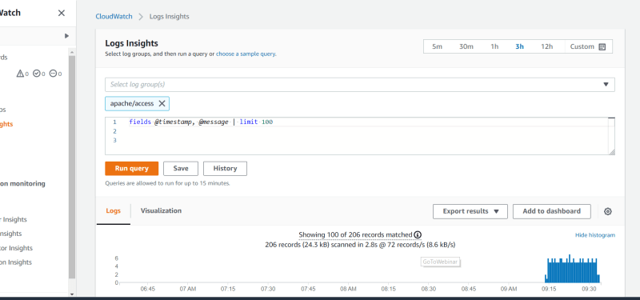
* show latest 50 log records  
  fields @timestamp, @message| sort @timestamp desc | limit 50  
  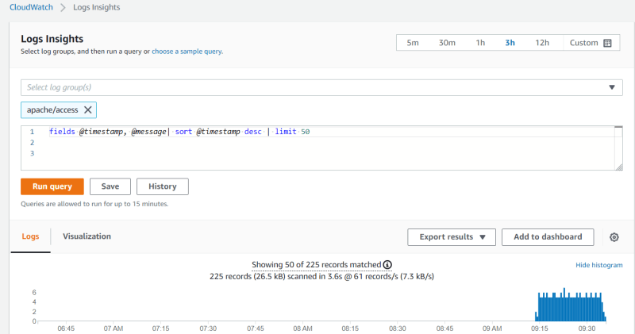
* Lets try to view the error logs with directory in message  
  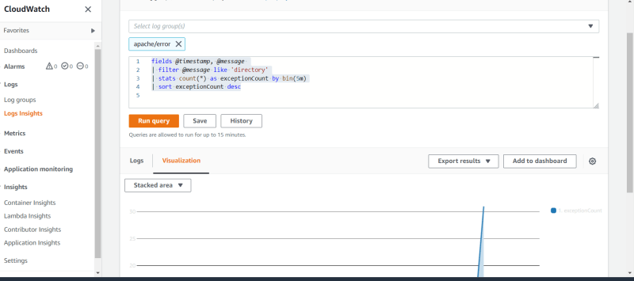
* Glob patterns & regular expression to extract fields
* <https://cheatography.com/davechild/cheat-sheets/regular-expressions/> for the regex cheat sheet